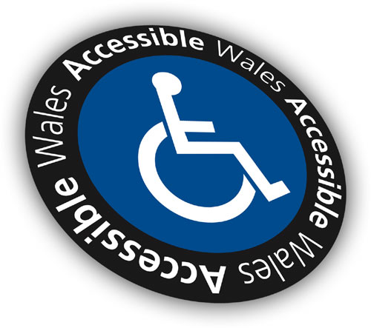

Accessible Wales
Pre Course Booking Form

Course Title:
Company Name:
Contact Name:
Position In Company:
Address Of Company:
Post Code:
Telephone Number:

Number of Delegates: _________ Date of Course: _________

During Full Day Courses a break for delegates to have lunch will be provided, delegates should bring lunch with them unless otherwise stated. Tea and coffee will be available. All booking forms should be returned and confirmed 14 days before course date.

Photographs/Videos will be taken on this day for marketing purposes, please tick here if you are not happy for us to take photographs

Payment can be made in advance, on the day or fourteen days after the event. Please sign/type your name below to accept the details above and confirm the booking.

Signed: _______________________ Date: _________

Delegate Register

If you are booking more than one person on a course please provide us with a list of names

Course Title: ___________________ Date: ______

Company Name: ___________________

Name | Position | Email

Signed: _______________________ Date: _________

